(Approx. 1091 words)

Cut the Cord ???

By Phil Sorrentino, Contributing Writer, The Computer Club, FL

January 2019

www.scccomputerclub.org

Philsorr (at) yahoo.com

TV is definitely one of our favorite sources of entertainment. The entertainment is created by studios and TV networks and delivered by cable (coax), FIOS (fiber) or satellite (dish). The “cord” (or cable) is our connection to one of these providers. Usually, the same cord also connects us to the internet, and possibly even provides phone service. Much of what used to be available only as cable TV channels may now be available using the internet or by receiving local broadcast stations.

In an article I wrote a little over three years ago (7/15) I discussed the thought of “cutting the cord”, which if you’ll remember is basically eliminating the TV part of your cable service and therefore the TV expense from your cable bill. Most of us get both TV and Internet from our cable provider and some of us go one step further and have the “triple play”; TV, Internet, and Phone from them. So, in order to cut the cord, meaning leaving only the Internet, we would have to replace the TV service (and possibly the Phone service), with equivalent services. The Phone is pretty straight forward, just find a less expensive service that uses “Voice over the Internet” or VOIP, like Magic Jack or Ooma. The harder part is replacing the entertainment that we get from all the cable channels. Many cable TV packages can include 200+ channels with a lot of special entertainment like ESPN and the History channel, and premium movie channels like HBO and Showtime. Many of these special channels may not be able to be replaced. But if you don’t take advantage of these special channels and are not too demanding in your choice of entertainment, then cutting the cord may be for you. You may be able to satisfy your TV entertainment needs by local broadcast TV augmented by the addition of a streaming device to your TV.

Local “broadcast” TV channels may satisfy a good portion of your entertainment and local (and national) news needs. Local TV channels can be received by an antenna and a broadcast tuner. Most modern TVs have both a tuner for cable (probably the default) and a tuner for broadcast. In the TVs settings or setup, there is typically a choice of “cable” or “air” (or something that indicates broadcast TV, like OTA). The “air” choice uses the broadcast tuner. It may not be well known, but the modulation schemes for these two transmission types are different. (Modulation scheme is the way the picture and sound is put on to a carrier signal for transmission.)

An indication of how successful you may be in receiving local broadcast signals can be found by going to the antennaweb.org website. Click “Click Here To Start”, and on the next screen enter your zip code, then click Submit. The resulting map will show you the broadcast stations that you may receive along with the distance to the transmitting antennas and the direction from your location. The distances and directions will help you decide if it is possible to receive the station and what type of antenna (indoor, outdoor, directional or omni-directional) may be needed. Here are the results for zip code 33573, Sun City Center, FL. All the major networks and a few local stations can be received using an indoor antenna.

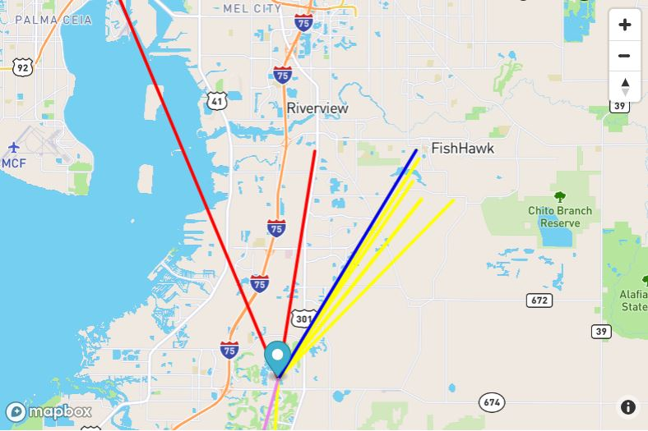

If you want to take advantage of broadcast TV and prefer to time-shift your TV watching, TiVo, SiliconDust, and Tablo make DVRs (Digital Video Recorder) for recording your shows. Don’t forget that you also need a “guide” so that you can schedule the recordings. The guide may be a monthly expense or it may be bundled into the cost of the device. Some DVRs even allow you to buzz through the commercials during playback.

In addition to local broadcast stations, some TV programs can be watched simply using a browser on your computer, or an APP on a Tablet or Smartphone. Many shows are available at [www.abc.com](http://www.abc.com), [www.cbs.com](http://www.cbs.com), [www.nbc.com](http://www.nbc.com), and [www.fox.com](http://www.fox.com). You can’t always get every episode of every show, but usually you can get the last few episodes of all of the major shows. Unfortunately, you will have to watch the commercials attached to the shows.

Streaming devices, the other part of replacing the Cable TV channels, can provide access to a collection of current shows and a large assortment of movies. Streaming devices can be as basic as the Roku Streaming Stick and the Amazon Fire stick, or as elaborate as Apple TV or nVidia ShieldTV. Each of these devices provides the ability to use Apps (clients) that can access the major streaming services.

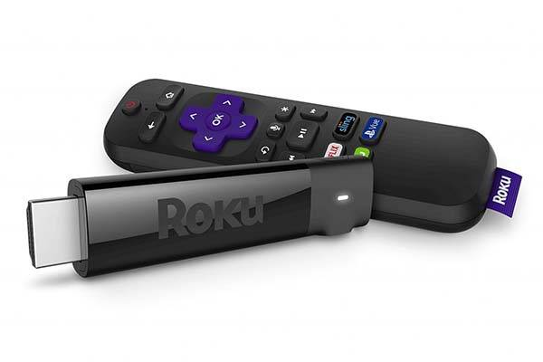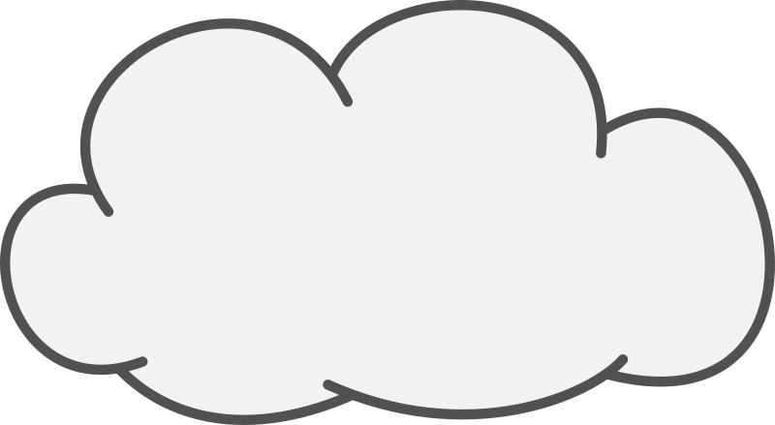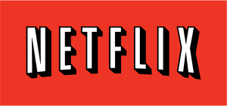

**Internet**

Client

These streaming devices act as the “clients” in Client-Server Technology where the Server is the Cloud Service that the client accesses for the streaming entertainment. Streaming entertainment may come from Netflix, Hulu, DirectTV Now, Amazon Prime Video, HBO Now, SlingTV, or YouTubeTV. And there are a host of lesser known services like, PhiloTV, Fubo, and Tubi. Most of these require a monthly subscription fee in the $10 to $40 per month range. Most will give you a one-month free trial. Tubi advertises itself as a free service that provides movies and TV shows. (And by the way, you can even stream music with the Pandora or Spotify free streaming music services.)

A streaming device is fairly easy to set up. Just connect it to your TV via one of the HDMI inputs on the TV, and get it on to your Wi-Fi (yes, you’ll need the Wi-Fi password). Once you have the streaming device set up, you might want to give Tubi (the free one) a try just to see how streaming works. And finally, if you don’t mind TV on a small screen, the Pluto TV Android App provides access to movies and some live TV channels.

When all is said and done, I suspect that many of us feel that we pay too much for the TV part of the cable bill, because of the ever-increasing cable bills for a collection of cable channels that we hardly ever use. But, on the other hand, most of us have gotten used to the fact that the TV service is convenient and familiar - we don’t have to learn anything new to use it. So although with the right combination of broadcast channels and streaming devices, cord cutting may be possible, is it the best thing for you to do? It’s your choice.